KMD Input File Format
Kinetically Derived Maximum Tolerated Dose File Format Explanation

Introduction
The sole purpose of this document is to inform the user of the file format required for the KMD Tool. The tool is available here: https://scitovation.shinyapps.io/plethem-MTD/
System Requirements:
Windows 10 with: Edge, Firefox, or Chrome
Mac OS 10.14.x or higher, with: Safari, Firefox, or Chrome
Ubuntu with: Firefox

File Format Requirements
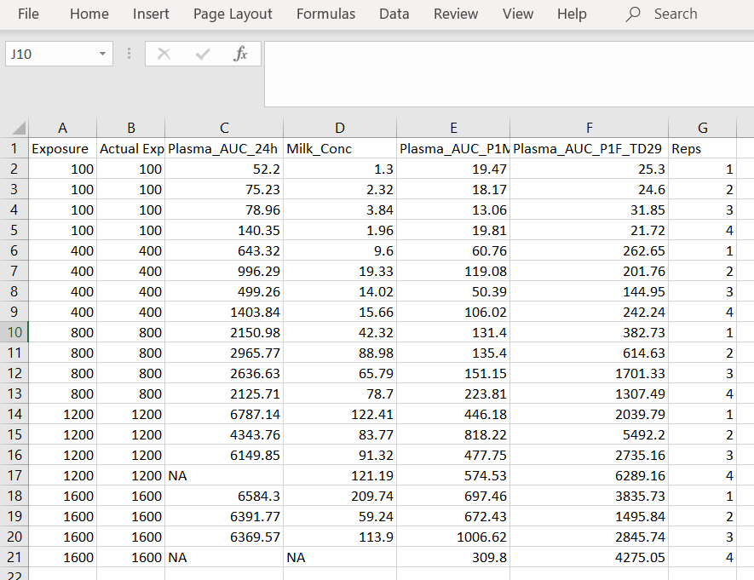
In figure 1 is an example of a PLETHEM input file. The file may be either an excel formatted file or a comma separated value formatted file. The first two columns should always contain the exposure followed by the actual exposure. Next there may be as many columns as the user desires of measured concentrations. In this case there are four but there could just as easily be more or less. If the user is missing data this should be include as an NA in the column. Last is the column identifying the replicate number.
Figure 1. Template for loading data into the KMD workflow.

